Lab – Installing PowerShell Empire On Kali Linux

**Overview –**

In this lab, you will be shown how to install PowerShell Empire on Kali Linux 2021.1. When it comes to PowerShell Empire, not all installation packages are created equal.

**Lab Requirements**

* One install of VirtualBox, with latest version and extension pack.
* One virtual install of Kali Linux, latest version.
* Snapshot of current configuration

**Install PowerShell Empire**

From your Kali desktop, open a new terminal window. At the prompt, copy and paste or type in the following command—press enter.

**cd /opt**



Clone PowerShell into your installation of Kali using the following command.

**git clone** [**https://github.com/BC-SECURITY/Empire.git**](https://github.com/BC-SECURITY/Empire.git)

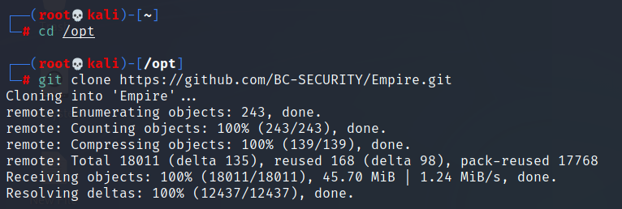

Once the downloaded has finished, copy and paste or type each of the commands one at a time into the terminal prompt.

* cd Empire/
* ls
* cd setup/
* ls

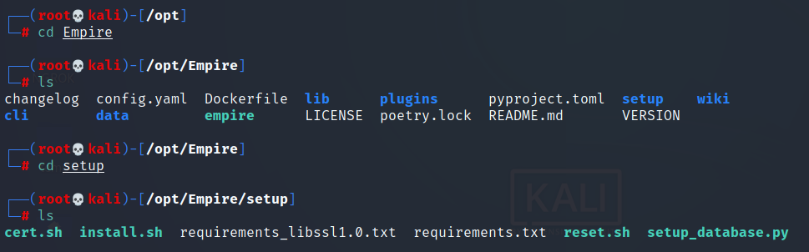

We next need to install the application running the **install.sh.** At the prompt, type in the following command.

**./install.sh**

Some files will need to be updated, and others will need to be downloaded, so be patient and do not interrupt the install!

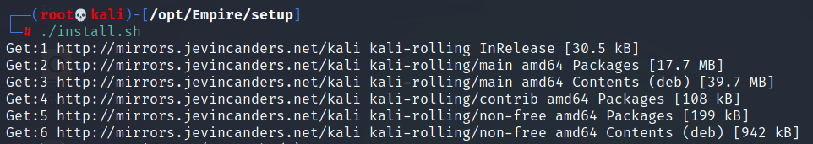

**Launch PowerShell Empire**

Move back one directory using the following command.

**cd ..**



Launch PowerShell Empire using the following command. Press enter.

**./empire**



PowerShell Empire launches.

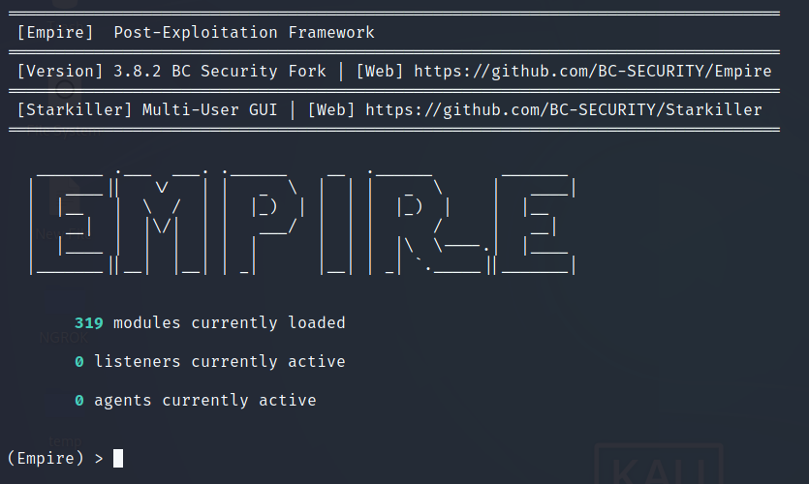

**Using the help command**

At the Empire prompt, type help to see what options are available.

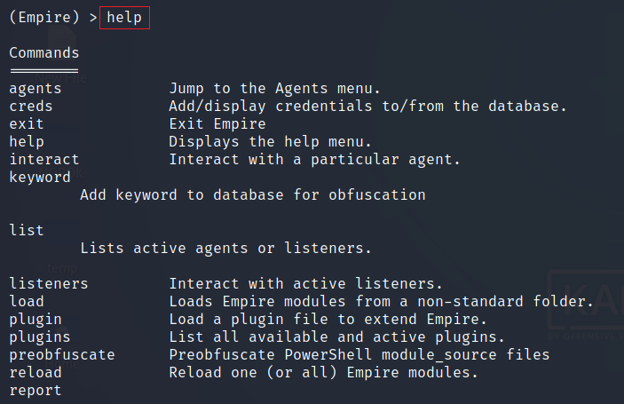

Beware that each time you need to launch PowerShell Empire, you will need to first change the location of your working folder over to the Empire directory.



**Summary –**

In this short lab, you got to install PowerShell Empire. There are plenty of tutorials on the Internet and YouTube that show you how to install PowerShell Empire. Because of upgrades with Kali and Python dependencies with the program, the older tutorials no longer work.

In our next lab, we will cover the basics of what you need to know to use the PowerShell Empire Framework. Stay tuned!